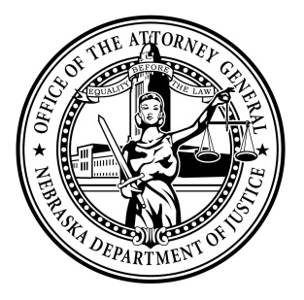Attorney General Doug Peterson

News Release

FOR IMMEDIATE RELEASE

January 18, 2022

Today, Attorney General Doug Peterson joined Governor Pete Ricketts and Colonel John Bolduc from the Nebraska State Patrol in recognizing National Human Trafficking Awareness Month.

Attorney General Peterson reviewed the collaborative work done by many agencies in bringing about some ground-breaking investigations and prosecutions this past year. His office released the Nebraska Human Trafficking Task Force Update that outlines prosecutions and training numbers for 2021.

“We stand ready on behalf of Nebraskans to investigate and prosecute any human trafficking case anywhere in the state. For five years, we have been organizing regionally to make certain we are ready to investigate and stop any trafficking we uncover. The teams are also prepared to make sure each victim involved has access to all the available lifelines,” stated Attorney General Peterson.

The Nebraska Department of Transportation continues to manage human trafficking hotline posters in every rest area on I-80. The current posters have both the National Human Trafficking Hotline and a QR code that immediately takes a person to the [Attorney General’s website](https://ago.nebraska.gov/identifying-trafficking-0), to learn the different signs of trafficking. The poster, printed in both English and Spanish, provides the National Human Trafficking Hotline number: 1-888-373- 7888, which is available to receive calls 24 hours a day, seven days a week, 365 days a year. The hotline funnels calls to the in-state network established by the Nebraska Human Trafficking Task Force (NHTTF). Help is available in English, Spanish, and more than 200 additional languages through an on-call interpreter.

Agencies and organizations representing 12 groups attended the event and proclamation signing.

To learn more about NHTTF and human trafficking in Nebraska, visit <https://ago.nebraska.gov/combating-human-trafficking>

###

*2021 Nebraska Human Trafficking Task Force Update Attached*

Suzanne Gage

Director of Communications

Nebraska Attorney General

Office: 402.471.2656

Mobile: 402.560.3518

[Suzanne.gage@nebraska.gov](mailto:Suzanne.gage@nebraska.gov)

[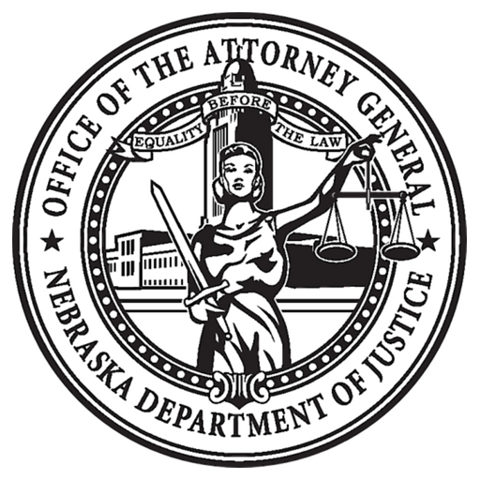](https://ago.nebraska.gov/)   [](https://twitter.com/agdougpeterson)   [](https://www.facebook.com/AGDougPeterson/)