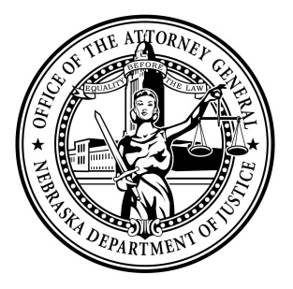Attorney General Doug Peterson

News Release

FOR IMMEDIATE RELEASE

January 7, 2022

Yesterday, Jake Gonzalez was sentenced in Jefferson County District Court after being found guilty of child abuse resulting in a death and terrorist threats. The victim was a two-year-old child from Fairbury, Nebraska. Judge Vicky Johnson sentenced 19-year-old Gonzalez to 70 to 80 years in prison for count one, child abuse resulting in death, and 3 to 3 years in prison for count two, terroristic threats. In a companion case, Gonzalez was also sentenced to 20 to 20 years in prison for attempted assault in the first degree. All sentenced were ordered to run concurrently.

The Jefferson County Sheriff’s Office and the Nebraska State Patrol assisted in the investigation. The Attorney General’s Office prosecuted the case.

###

Suzanne Gage

Director of Communications

Nebraska Attorney General

Office: 402.471.2656

Mobile: 402.560.3518

[Suzanne.gage@nebraska.gov](mailto:Suzanne.gage@nebraska.gov)

[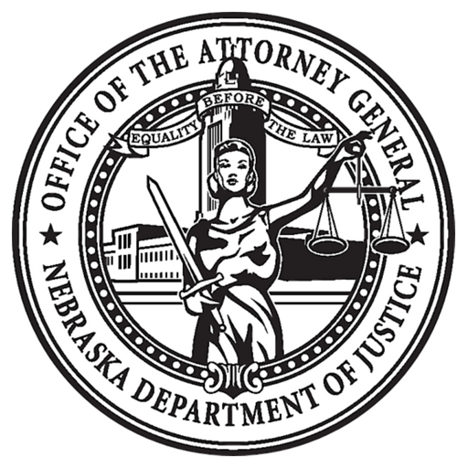](https://ago.nebraska.gov/)   [](https://twitter.com/agdougpeterson)   [](https://www.facebook.com/AGDougPeterson/)