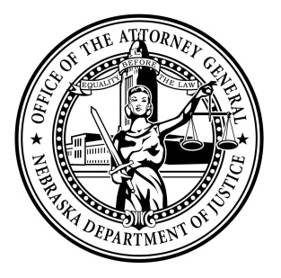Attorney General Doug Peterson

News Release

FOR IMMEDIATE RELEASE

January 10th, 2022

(Lincoln) Today, Attorney General Doug Peterson urged the Federal Communications Commission (FCC) to put in place measures that will help stem the tide of foreign-based illegal robocalls that attempt to scam Americans. Today’s comment letter to the FCC was led by North Carolina Attorney General Josh Stein, Pennsylvania Attorney General Josh Shapiro, and Arkansas Attorney General Leslie Rutledge.

“Robocalls are a major concern to Nebraskans. Scam calls can result in real financial losses and serious consumer frustration. Our office is committed to using every tool at its disposal, working closely with all available partners, to combat unlawful robocalls and spoofing,” stated Attorney General Doug Peterson

Attorney General Doug Peterson and a bipartisan group of 51 attorneys general are calling for the FCC to require gateway providers – the companies that allow foreign calls into the United States – to take steps to reduce how easily robocalls have been able to enter the U.S. telephone network, including implementing STIR/SHAKEN, a caller ID authentication technology that helps prevent spoofed calls. Gateway providers should be required to implement this technology within 30 days of it becoming a rule to help eliminate spoofed calls and to make sure that international calls that originate from U.S. telephone numbers are legitimate. In December, Attorney General Doug Peterson and a coalition of 51 attorneys general successfully helped to persuade the FCC to shorten by a year the deadline for smaller telephone companies to implement STIR/SHAKEN.

The attorneys general are asking the FCC to require these gateway providers to take additional measures to reduce robocalls, including:

* Responding to requests from law enforcement, state attorneys general, or the FCC to trace back calls within 24 hours.
* Blocking calls when providers are aware of an illegal or likely fraudulent caller.
* Blocking calls that originate from numbers that are on a “do not originate” list – such as government phone numbers that are for incoming calls only.
* Ensuring that foreign telephone companies they partner with are ensuring that calls are being made from legitimate numbers.

The attorneys general are also encouraging the FCC to require all phone companies to block calls from a gateway provider if it fails to meet these requirements. Illegal robocalls are a scourge – in 2020, Americans lost more than $520 million through robocall scams.

Attorney General Doug Peterson is joined in sending this letter to the FCC by the Attorneys General of Alabama, Alaska, Arizona, Arkansas, California, Colorado, Connecticut, Delaware, District of Columbia, Florida, Georgia, Hawaii, Idaho, Illinois, Indiana, Iowa, Kansas, Kentucky, Louisiana, Maine, Maryland, Massachusetts, Michigan, Minnesota, Mississippi, Missouri, Montana, Nevada, New Hampshire, New Jersey, New Mexico, New York, North Carolina, North Dakota, Ohio, Oklahoma, Oregon, Pennsylvania, Rhode Island, South Carolina, South Dakota, Tennessee, Texas, Utah, Vermont, Virginia, Washington,

West Virginia, Wisconsin, and Wyoming.

###

Suzanne Gage

Director of Communications

Nebraska Attorney General

Office: 402.471.2656

Mobile: 402.560.3518

[Suzanne.gage@nebraska.gov](mailto:Suzanne.gage@nebraska.gov)

[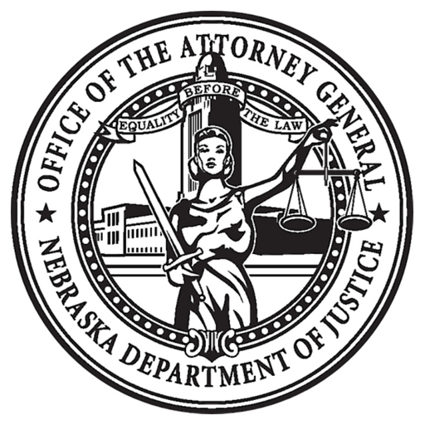](https://ago.nebraska.gov/)   [](https://twitter.com/agdougpeterson)   [](https://www.facebook.com/AGDougPeterson/)