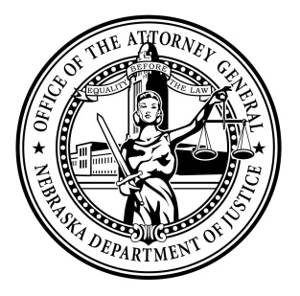Attorney General Doug Peterson

News Release

FOR IMMEDIATE RELEASE

October 22, 2021

**Attorney General’s Office Response to Kopke Sentence:**

The Attorney General‘s Office is disappointed with the sentence issued today in the case of Patrick Kopke. We intend to appeal the matter. Mr. Kopke was put in a position of public trust. He violated that trust and pled to a felony. The State asked the court for a five to ten-year prison sentence. We believe the sentence issued of 30 days in jail, 15 years of probation, and restitution is inadequate. His felony act involved embezzling over $150,000 from the State Fair Board.

###

Suzanne Gage

Director of Communications

Nebraska Attorney General

Office: 402.471.2656

Mobile: 402.560.3518

[Suzanne.gage@nebraska.gov](mailto:Suzanne.gage@nebraska.gov)

[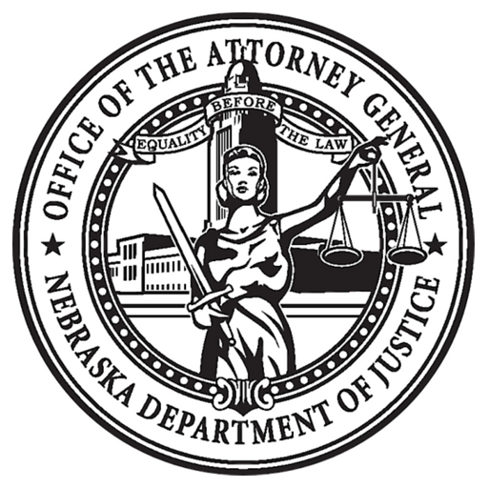](https://ago.nebraska.gov/)   [](https://twitter.com/agdougpeterson)   [](https://www.facebook.com/AGDougPeterson/)